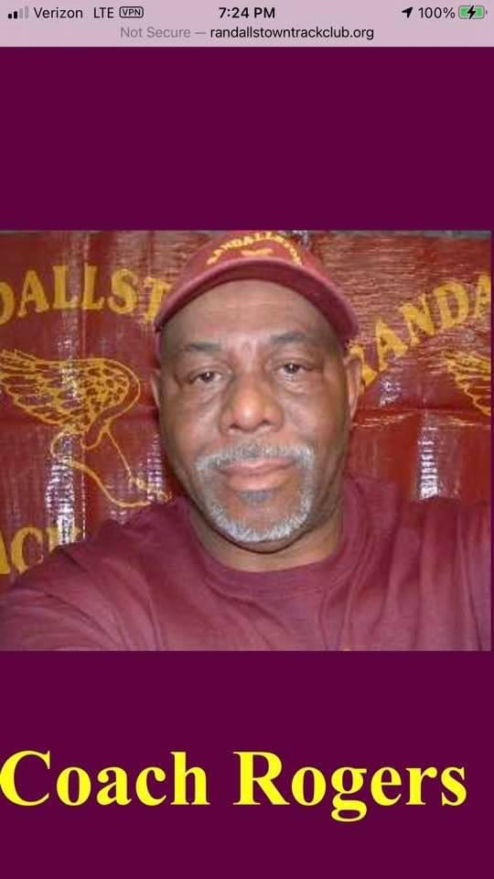
CONDOLENCES to the family of Coach Felix Rogers, Coach of Randallstown Track Club and USATF official.

Services for Felix Albert Rogers are as follows:

Viewing: Feb 12th 3p-4p family, 4p-7p public.
Capacity for the viewing is socially distanced at 25 people, however people can come and go. Face masks are required.

Funeral: Feb 13th 10a.
Capacity for the track and field community is socially distanced at 60 people. Face masks are required.

Location: Vaughn Greene Funeral Home –
8728 Liberty Rd
Randallstown, MD 21133

In lieu of flowers, please consider making a donation.
For those who cannot attend, the funeral will be live-streamed. We will notify you once a link is created.
Donations can be made via cashapp $malikaorogers , Venmo @MalikaORogers , or Zelle (410)236-1035. Contact Malika Rogers if you have any questions.

